Stop Malaria− Combating Malaria in Nyabondo and Malindi, Kenya

Project Background
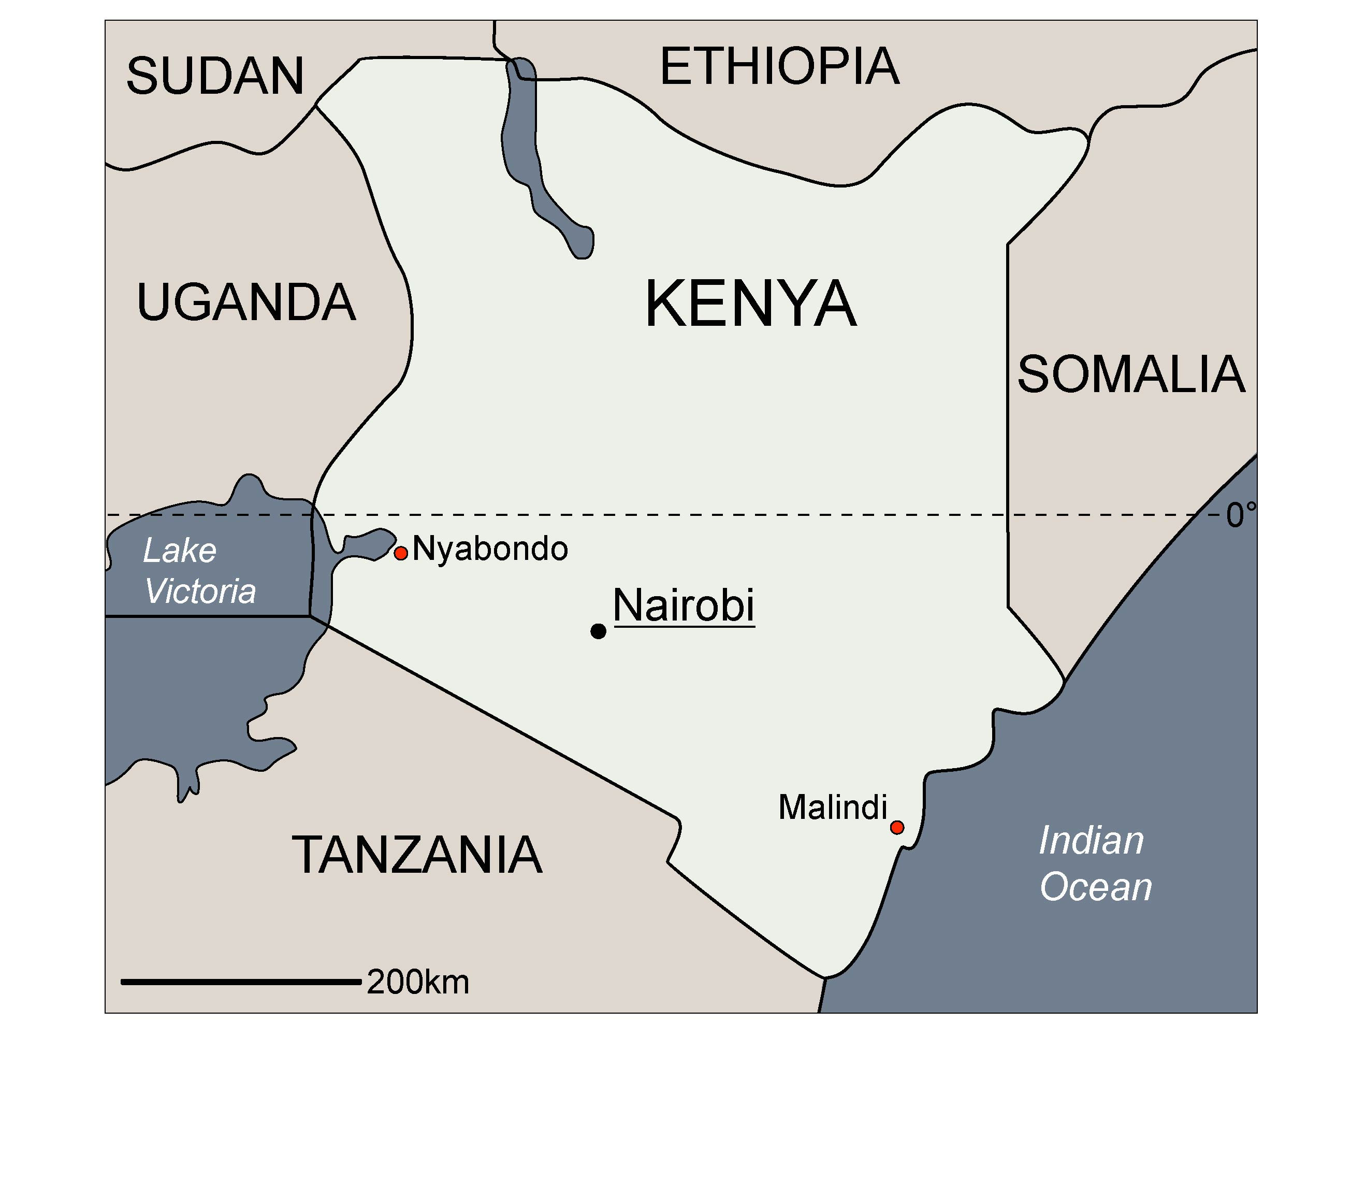
Every year around 2 million people worldwide die from the effects of the tropical disease malaria, most in sub-Saharan Africa. The female Anopheles mosquito transmits the malaria pathogen. icipe’s malaria programme is based upon ‘Integrated Vector Management’ (IVM). IVM is one of the best alternative methods to conventional chemical approaches to preventing diseases transmitted by insects. ‘Adaptive management’ principles stipulate active participation of the population.
The cornerstone of ‘adaptive management’ is decision support for the people through participation in integrated, sustainable problem-solving processes.

Project Description

The starting points vary in the two pilot project areas:
The project area in Nyabondo in West Kenya, lies 1560 metres above sea level on a high plateau. The high plain was formerly a wetland, which, thanks to a well-functioning drainage system has been malaria free. The construction of hand-made clay bricks created holes scattered around the plain that filled with water. The thousands of small stagnant pools present ideal breeding grounds for mosquito larvae. Malaria spreads quickly to the settlements that are located close to the breeding sites.
The urban area around Malindi, on the coast of the Indian Ocean, offers malaria mosquitoes many breeding sites, all created by man: potholes, open wells, stagnant pools caused by clogged canals, sewage, etc. In hotel facilities, where pools are not used during the rainy season, many more breeding sites are created. This contributes to the quick spread of malaria in this urban area.
Integrated vector management for reduction of malaria prevalence is based upon three pillars: the first pillar of the project is education. The affected people are informed and sensitised to the danger presented by stagnant pools as breeding areas for the malaria mosquitoes. These pools are drained in community work. Where this is not possible, the second pillar comes into force: stagnant bodies of water are treated with an environmentally compatible bacteria (Bti, Bacillus thuringiensis israelensis), to decimate the mosquitoes at the larvae stage in their breeding areas.
The third pillar consists of the distribution of impregnated bed nets to the inhabitants of Nyabondo and Malindi. When used correctly these mosquito nets are the surest protection from mosquito bites.

Initial and subsequent training of native persons to the level of so-called ‘Malaria Scout’ is of great importance. They ensure sustainable malaria control for the future. Additional co-operation takes place with local authorities and grassroots organisations.

Development Goal

Reduction in malaria prevalence through controlled restriction of the sources of the Anopheles mosquito.

Operational Objectives

1. Informing/mobilisation of the population and education of local trainers (mosquito scouts) in the integrated methods of malaria prevention (IVM, ‘adaptive management’, Environment/ Water Management).
2. Education of local population in Bti treatment technology for stagnant bodies of water.
3. Instruction and distribution of impregnated bed nets (the aim is that 70% of the population in Nyabondo and Malindi will be able to sleep under bed nets).
4. Scientific surveys (entomological and environmental) undertaken to better understand the interrelationship between mosquito sources and incidence of malaria (intervention model).
5. Monitoring of malaria cases and regular information exchange with state authorities to improve the state health programme.

Set-Up
Operative
Partner Organisations: icipe (www.icipe.org)
Project Co-ordinator: Dr. John Githure, Human Health Division Head, icipe
Local Project Leader:
Malindi: Dr. Charles Mbogo, KEMRI
Nyabondo: Dr. Francois X. Omlin, icipe
Local Project Partners: KEMRI (Kenyan Medical Research Centre), PUMMA (Malindi Mosquito Control Association of 10 local NGOs), 7 local NGOs and self-help groups in Nyabondo
Additional Project
Partners: ETH Zurich, Swiss Mosquito Control Agency Meilen, Università di Reggio Calabria
Beneficiaries: Nyabondo and Malindi communities, >120,000 people

Project Framework
Project running
since:
Nyabondo: 2004
Malindi: 2005
Project Duration
Phase II:
Nyabondo: June - December 2006
Malindi: May 2006 - April 2007
Budget for 2006:
Nyabondo: 130,000 USD
Malindi
(until April 2007): 144,000 USD
Supported by: generated funds;
bed nets: FAWCO (www.fawco.org); and Worldswim for Malaria (www.worldswimformalaria.com)
BioVision
Co-ordination:
Programme
and Project: Verena Albertin (v.albertin@biovision.ch)
Bed Nets
and Lobbying: Andreas Schriber (a.schriber@biovision.ch)

