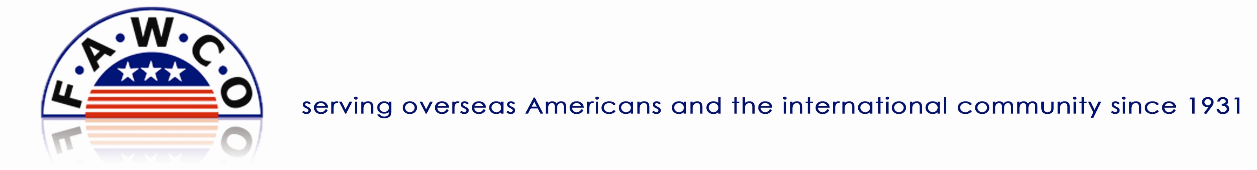

Club Workshop Request Form

Contact Information
Please type the following information.
Club Name |  | Region:
Club Address
Town Postcode
Requestor Name
Phone
Email
Skype Name

Request Form
Please type the workshop(s) or presentation(s) that you are interested in for your club.

Presentations

Workshops

Criteria
Please take a moment to complete the following questions to provide us with initial information to fulfill your request. Double-click on the shaded box and select checked from the upper right menu box.

Audience Options

Club Board Members
Club Members
Club Members and Guests
Presentation/Workshop will be at a Regional Meeting

Format Options
1-2 hour onsite session
1-hour webinar or Skype (via internet)
Half-day workshop
Video followed by an interactive Q&A on Skype

The Request Process
Once we have received your request, Mary Adams, the Club Workshops Coordinator, will contact you to further discuss the logistics, expectations, and process.

